CO2
B.​Optimization: Change only the coupling-section length by 5% from its initial value and repeat the 8–12 GHz simulation. Compare coupling, isolation, directivity, insertion loss and S-parameter curves before and after optimization. Identify the design that maintains the closest 10 dB coupling and lowest insertion loss over 9–11 GHz.

EXPERIMENT B: OPTIMIZATION OF A MICROWAVE DIRECTIONAL COUPLER

1. AIM
To optimize the microwave directional coupler by changing the coupling-section length by 5% from its initial value, simulate the response over 8–12 GHz using MATLAB, and compare the performance before and after optimization.

2. SOFTWARE USED
MATLAB

3. MATLAB CODE
Paste the MATLAB program used for the original and optimized designs in this section.
The modified design must change only the coupling-section length by 5%, while keeping all other parameters constant.

%% ALL 5 FIGURES IN ONE MATLAB WINDOW
figure(1);
clf;

% Plot 1: S11
subplot(3,2,1);
plot(fGHz,S11AdB,'b','LineWidth',1.6);
hold on;
plot(fGHz,S11BdB,'r--','LineWidth',1.6);
grid on;
xlabel('Frequency (GHz)');
ylabel('S11 (dB)');
title('Input Return Response');
legend('Initial','Length +5%','Location','best');
xlim([8 12]);

% Plot 2: S21
subplot(3,2,2);
plot(fGHz,S21AdB,'b','LineWidth',1.6);
hold on;
plot(fGHz,S21BdB,'r--','LineWidth',1.6);
grid on;
xlabel('Frequency (GHz)');
ylabel('S21 (dB)');
title('Through-Port Response');
legend('Initial','Length +5%','Location','best');
xlim([8 12]);

% Plot 3: S31
subplot(3,2,3);
plot(fGHz,S31AdB,'b','LineWidth',1.6);
hold on;
plot(fGHz,S31BdB,'r--','LineWidth',1.6);
yline(-10,'k:','10 dB target');
grid on;
xlabel('Frequency (GHz)');
ylabel('S31 (dB)');
title('Coupled-Port Response');
legend('Initial','Length +5%','Target','Location','best');
xlim([8 12]);

% Plot 4: S41
subplot(3,2,4);
plot(fGHz,S41AdB,'b','LineWidth',1.6);
hold on;
plot(fGHz,S41BdB,'r--','LineWidth',1.6);
grid on;
xlabel('Frequency (GHz)');
ylabel('S41 (dB)');
title('Isolated-Port Response');
legend('Initial','Length +5%','Location','best');
xlim([8 12]);

% Plot 5: Coupling comparison
subplot(3,2,5);
plot(fGHz,-S31AdB,'b','LineWidth',1.6);
hold on;
plot(fGHz,-S31BdB,'r--','LineWidth',1.6);
yline(10,'k:','10 dB target');
xline(9,'k:');
xline(11,'k:');
grid on;
xlabel('Frequency (GHz)');
ylabel('Coupling (dB)');
title('Coupling Comparison (9-11 GHz)');
legend('Initial','Length +5%','Target','Location','best');
xlim([8 12]);

% Plot 6th cell: Insertion-loss comparison
subplot(3,2,6);
plot(fGHz,-S21AdB,'b','LineWidth',1.6);
hold on;
plot(fGHz,-S21BdB,'r--','LineWidth',1.6);
grid on;
xlabel('Frequency (GHz)');
ylabel('Insertion Loss (dB)');
title('Insertion Loss Comparison');
legend('Initial','Length +5%','Location','best');
xlim([8 12]);

% Overall title
sgtitle('Question B: Directional Coupler Optimization - 5% Length Change');

% Set figure size for a clear layout
set(gcf,'Position',[100 50 1100 850]);

4. OUTPUT
The MATLAB simulation is performed over the frequency range of 8–12 GHz for both the original and optimized designs.
The S-parameter curves before and after optimization are compared to analyze:
- Coupling
- Isolation
- Directivity
- Insertion loss
- Reflection and transmission characteristics
The performance is evaluated over the frequency range of 9–11 GHz to identify the design that maintains coupling closest to the target of 10 dB the lowest insertion loss.

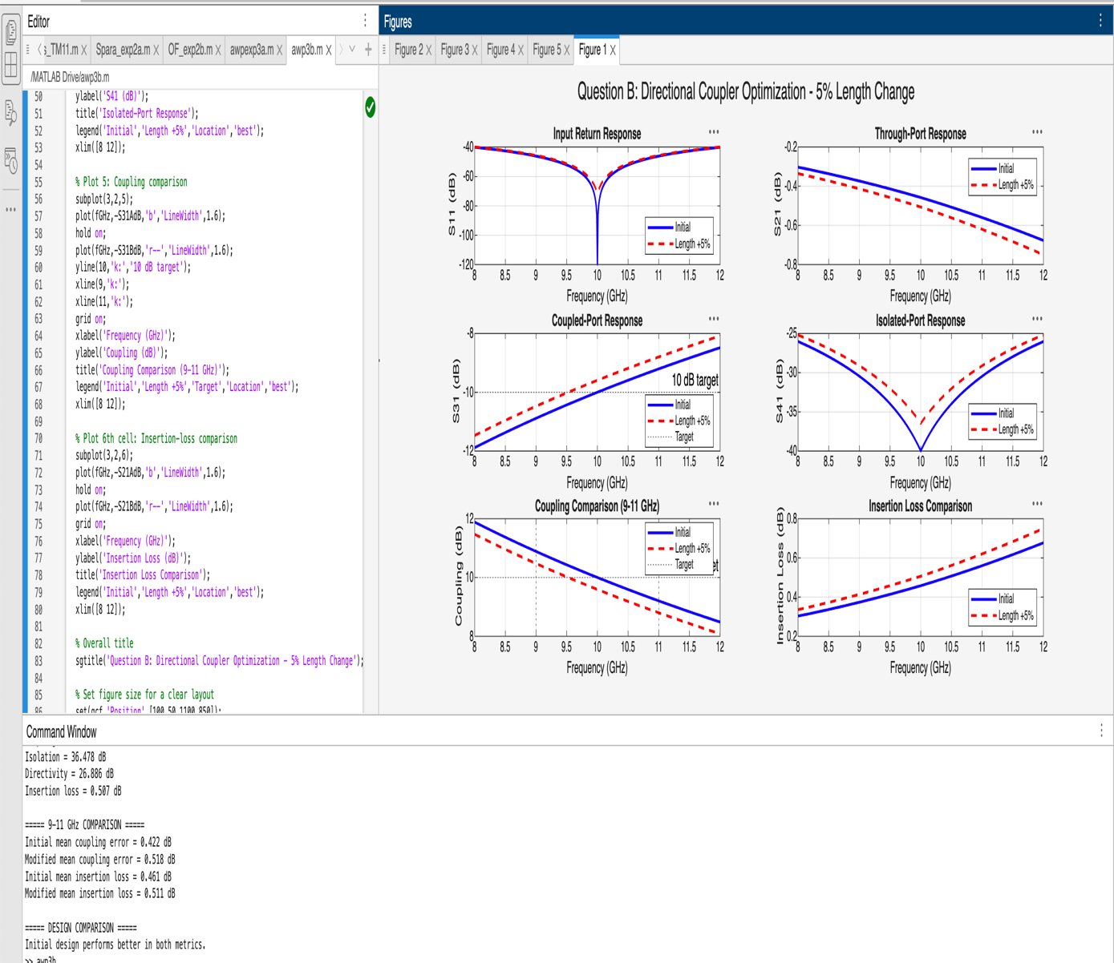

5. RESULT
The microwave directional coupler was analyzed before and after changing the coupling-section length by 5%. The S-parameter responses and performance characteristics were compared over the frequency range of 8–12 GHz. The preferred design is identified based on its ability to maintain coupling close to 10 dB and achieve low insertion loss over 9–11 GHz.

